**Classical Thinking**

|  |  |
| --- | --- |
| **2.0** | **Introduction** |

**1.** In Whittaker’s system of classification, prokaryotes are placed in Kingdom

(A) Monera (B) Protista

(C) Plantae (D) Fungi

<A>

**2.** The drawback/s or limitation/s of two kingdom classification is/are

(A) photosynthetic and non-photosynthetic organisms are placed together.

(B) that it cannot distinguish between unicellular and multicellular organisms.

(C) that it cannot distinguish between eukaryotes and prokaryotes.

(D) all of the above

<D>

**3.** Three domain system of classification includes _______ kingdoms.

(A) 3 (B) 4

(C) 6 (D) 7

<C>

**4.** True nucleus is absent in:-

(A) *Mucor* (B) *Vaucheria*

(C) *Volvox* (D) *Anabaena*

<D>

|  |  |
| --- | --- |
| **2.1** | **Kingdom Monera** |

**5.** *Nitrobacter* can oxidize nitrites to nitrates. *Nitrobacter* is

(A) photosynthetic autotroph

(B) parasitic

(C) chemosynthetic autotroph

(D) heterotrophic

<C>

**6.** Archaebacteria differ from other bacteria in

(A) cell wall structure

(B) mode of nutrition

(C) cell shape

(D) mode of reproduction

<A>

**7.** Cyanobacteria are classified under

(A) Protista (B) Plantae

(C) Monera (D) Algae

[NCERT – Exemplar]

<C>

**8.** Which feature of cyanobacteria enables them to form blooms in nutrient-rich water bodies?  
(A) Presence of flagella  
(B) Thick cell wall with silica  
(C) Presence of chloroplasts for photosynthesis  
(D) Gelatinous sheath surrounding colonies

<D>

**9.** Citrus canker is caused by which of the following organisms?

(A) Fungi (B) Diatoms

(C) Bacteria (D) Slime moulds

<C>

**10.** Which of the following features sets Mycoplasma apart from all other bacterial species?

(A) DNA

(B) Ribosomes  
(C) Cell wall

(D) Plasma membrane

<C>

Mycoplasma lack a cell wall, distinguishing them from other bacteria which typically have a peptidoglycan cell wall.

**11.** A microbiologist isolates a prokaryote from a salt pan. Laboratory analysis shows it can grow only in highly saline water and has a unique cell wall structure. To which group from Kingdom Monera does it belong?

(A) Thermoacidophiles  
(B) Methanogens  
(C) Halophiles  
(D) Cyanobacteria

<C>

**12.** A respiratory pathogen is unaffected by penicillin and survives without oxygen. Based on the text, it most likely belongs to:  
(A) Cyanobacteria (B) Mycoplasma  
(C) Archaebacteria (D) Methanogens

<B>

Mycoplasma lack cell wall (resistant to penicillin) and can survive without oxygen.

**13.** Which feature differentiates archaebacterial cell walls from eubacterial cell walls?  
(A) Chitin in cell wall  
(B) Absence of peptidoglycan  
(C) Cellulose in cell wall  
(D) Presence of chloroplasts

<B>

Archaebacterial walls lack peptidoglycan; instead have unique polymers.

|  |  |
| --- | --- |
| **2.2** | **Kingdom Protista** |

**14.** Kingdom Protista contains

(A) multicellular eukaryotes

(B) unicellular prokaryotes

(C) multicellular prokaryotes

(D) unicellular eukaryotes

<D>

**15.** Naked cytoplasm, multinucleated and saprophytic are the characteristics of

(A) Monera (B) Protista

(C) Fungi (D) Slime moulds

[NCERT – Exemplar]

<D>

**16.** All eukaryotic unicellular organisms belong to

(A) Monera (B) Protista

(C) Fungi (D) Bacteria

[NCERT – Exemplar]

<B>

**17.** Which of the following can be used in filtration of oils and syrups?

(A) Pellicle of euglenoids

(B) *Trypanosoma*

(C) Diatomaceous earth

(D) *Gonyaulax*

<C>

**18.** Golden algae belongs to _______.

(A) Dinoflagellates (B) Chrysophytes

(C) Cyanobacteria (D) Euglenoids

<B>

**19.** Red oceanic tides can be due to

(A) diatoms (B) dinoflagellates

(C) red algae (D) blue-green algae

<B>

Red tides of oceans are due to excessive growth of dinoflagellates like *Gymnodinium* and *Gonyaulax*.

**20.** Which of the following is FALSE about slime moulds?

(A) They are saprophytes.

(B) They show an aggregation called as Plasmodium.

(C) They possess spores with true walls.

(D) They cause the disease, sleeping sickness.

<D>

Protozoans cause sleeping sickness.

**21.** Kingdom Protista contains

(A) *Euglena*, Dinoflagellates and *Puccinia*

(B) *Amoeba, Paramecium,* and *Hydra*

(C) *Euglena, Paramecium* and Mushroom

(D) *Amoeba, Paramecium* and Dinoflagellates

<D>

*Amoeba* and *Paramecium* are protozoan protist and dinoflagellates are photosynthetic protist.

***Think out of the box***

As we know that *Amoeba* and *Paramecium* are protists, thus Option (B), (C) and (D) are the possible answers. But *Hydra* is a member of Kingdom Animalia and mushroom belongs to Kingdom fungi.

Therefore, the possibilities of options (B) and (C) get eliminated and option **(D)** is the correct answer.

**22.** Chrysophytes

(A) are commonly called dinoflagellates and desmids.

(B) have pellicle instead of cell wall.

(C) are parasitic forms causing disease in animals.

(D) have indestructible wall layer deposited with silica.

<D>

|  |  |
| --- | --- |
| **2.3** | **Kingdom Fungi** |

**23.** Which of the following characteristics is unique to fungi and not found in any group of plants?

(A) Presence of cell wall

(B) Presence of vacuole

(C) Chitin in the cell wall

(D) Asexual spore formation

<C>

**24.** Which one of the following statement is TRUE about imperfect fungi?

(A) Only asexual phases of these fungi are known.

(B) They include toadstools and puffballs.

(C) They reproduce exclusively by sexual spores.

(D) They include members like morels and truffles.

<A>

Imperfect fungi (Deuteromycetes) are characterized by having only asexual reproductive phases known, with no observed sexual reproduction.

**25.** _______ is NOT a group included under Kingdom Fungi.

(A) Chrysophytes (B) Phycomycetes

(C) Ascomycetes (D) Deuteromycetes

<A>

**26.** Toadstools are

(A) dinoflagellates (B) fungi

(C) sporozoans (D) eubacteria

<B>

**27.** Which of the following is a correct match of class and spore type?

(A) Ascomycetes – Basidiospores

(B) Basidiomycetes – Oospores

(C) Ascomycetes – Ascospores

(D) Phycomycetes – Conidia

<C>

(A) Ascomycetes – Ascospores

(B) Basidiomycetes – Basidiospores

(D) Phycomycetes – Zoospores or Aplanospores

**28.** Zygospores are formed in

(A) *Puccinia* (B) *Penicillium*

(C) *Alternaria* (D) *Rhizopus*

<D>

Zygospores are formed by fusion of gametes in phycomycetes.

**29.** The dikaryophase (n+n) is a characteristic feature of ______.

(A) Deuteromycetes only

(B) Phycomycetes only

(C) Ascomycetes only

(D) Ascomycetes and Basidiomycetes

<D>

In both Ascomycetes and Basidiomycetes, plasmogamy is not immediately followed by karyogamy, leading to a dikaryotic condition.

**30.** Reproduction in fungi occurs by vegetative means by all of the following, except

(A) fragmentation (B) fission

(C) budding (D) meiosis

<D>

**31.** With respect to fungal sexual cycle, choose the CORRECT sequence of events.

(A) Karyogamy, Plasmogamy and Meiosis

(B) Meiosis, Plasmogamy and Karyogamy

(C) Plasmogamy, Karyogamy and Meiosis

(D) Meiosis, Karyogamy and Plasmogamy

[NCERT – Exemplar]

<C>

**32.** Puffball is a/an

(A) fungus (B) alga

(C) moss (D) protist

<A>

The species of genus *Lycoperdon* are commonly called puffballs. They have ball-shaped basidiocarps which send out puffs of spores. Young puffballs are edible.

**33.** Identify the INCORRECT match.

(A) *Claviceps* – Smut

(B) *Rhizopus* – Bread mould

(C) *Puccinia* – Rust fungus

(D) *Agaricus* – Mushroom

<A>

*Ustilago* – Smut

**34.** The imperfect fungi which are decomposers of litter and help in mineral cycling belong to:

(A) Basidiomycetes (B) Phycomycetes

(C) Ascomycetes (D) Deuteromycetes

<D>

|  |  |
| --- | --- |
| **2.4** | **Kingdom Plantae** |

**35.** Find the INCORRECT pair regarding Kingdom Plantae.

(A) Cell type − Eukaryotic

(B) Cell wall − Cellulose

(C) Alternation of generation − Sporophytic / gametophytic

(D) Mode of nutrition − Holozoic

<D>

Mode of nutrition − Autotrophic

Very few members of kingdom Plantae are heterotrophs such as Bladderwort, Venus fly trap, *Cuscuta*, etc.

**36.** A researcher finds a multicellular organism with cellulose cell wall and chlorophyll a and b. It produces embryos during development. Which kingdom does it belong to?

(A) Plantae (B) Protista

(C) Animalia (D) Monera

<A>

|  |  |
| --- | --- |
| **2.5** | **Kingdom Animalia** |

**37.** Select the INCORRECT statement from the following.

(A) In animals, sexual reproduction occurs by copulation followed by embryological development.

(B) Members of Kingdom Animalia are heterotrophic and show cell wall made up of cellulose.

(C) Members of Kingdom Animalia show holozoic mode of nutrition.

(D) In Kingdom Animalia, higher forms show nervous system and specialized sense organs.

<B>

Cell wall is absent in Members of Kingdom Animalia.

**38.** Which one of the following is NOT the salient feature of Kingdom Animalia?

(A) Heterotrophic and eukaryotic organisms.

(B) Multicellular organisms with indefinite growth.

(C) Higher forms exhibit sensory and neuromotor mechanism.

(D) Sexual reproduction by copulation.

<B>

Animals follow a definite growth pattern.

**39.** Pick up the WRONG statement.

(A) Nuclear membrane is present in Monera.

(B) Cell wall is absent in Animalia.

(C) Protista have photosynthetic and heterotrophic modes of nutrition.

(D) Some fungi are edible.

<A>

The members of Kingdom Monera lack nuclear membrane.

|  |  |
| --- | --- |
| **2.6** | **Viruses, Viroids , Prions and Lichens** |

**40.** Viruses are non-cellular organisms but replicate themselves once they infect the host cell. To which of the following kingdom do viruses belong to?

(A) Monera

(B) Protista

(C) Fungi

(D) None of the above

[NCERT – Exemplar]

<D>

**41.** Which type of nucleic acid is present in TMV?

(A) ssRNA (B) dsRNA

(C) ssDNA (D) dsDNA

<A>

**42.** Which of the following statements best justifies why viruses are regarded as obligate parasites?

(A) They contain both DNA and RNA

(B) They can grow independently in nutrient media

(C) They require a host for metabolism and replication

(D) They reproduce by binary fission only inside cells

<C>

**43.** Which of the following is true for bacteriophages?

(A) They contain RNA only

(B) They infect animal cells only  
(C) They infect bacteria

(D) They lack a capsid

<C>

**44.** Viroids have

(A) single stranded RNA not enclosed by protein coat.

(B) single stranded DNA enclosed by protein coat.

(C) double stranded DNA enclosed by protein coat.

(D) double stranded RNA not enclosed by protein coat.

<A>

**45.** Association between mycobiont and phycobiont are found in

(A) Mycorrhiza (B) Root

(C) Lichens (D) BGA

[NCERT – Exemplar]

<C>

**46.** Potato spindle tuber disease is caused by

(A) animal virus (B) bacteria

(C) plant virus (D) viroids

<D>

**47.** Which of the following are most suitable indicators of SO2 pollution in the environment?

(A) Fungi (B) Lichens

(C) Conifers (D) Algae

<B>

**Critical Thinking**

|  |  |
| --- | --- |
| **2.0** | **Introduction** |

**48.** How many kingdoms contain eukaryotes in five kingdom classification?

(A) 4 (B) 3 (C) 2 (D) 1

<A>

**49.** According to five kingdom classification, Protista comprises

(A) all multicellular eukaryotes

(B) all prokaryotes

(C) all unicellular eukaryotes

(D) both prokaryotes and eukaryotes

<C>

**50.** Which of the following statement is NOT true for five kingdom system of classification?

(A) Unicellular eukaryotes were included in kingdom Protista.

(B) Fungi were included as subkingdom of kingdom Plantae.

(C) All prokaryotes were included in kingdom Monera.

(D) This system is based on criteria like cell structure, body organisation, mode of nutrition, etc.

<B>

In five kingdom system of classification, fungi were placed in a separate kingdom i.e. Kingdom fungi.

**51.** Complete the following table and opt for the appropriate answer.

|  |  |  |  |  |  |
| --- | --- | --- | --- | --- | --- |
| **Features** | **Five Kingdoms** | | | | |
| **Monera** | **Protista** | **Fungi** | **Plantae** | **Animalia** |
| **Cell type** | (i) | Eukaryotic | Eukaryotic | Eukaryotic | Eukaryotic |
| **Cell wall** | (ii) | Present in some | Present (chitin) | (iii) | Absent |
| **Organisation** | Cellular | Cellular | (iv) | Present | Present |

(A) **i** - Eukaryotic, **ii** - Present (Non cellulosic), **iii** - Absent, **iv** - Cellular

(B) **i** - Eukaryotic, **ii** - Present (Cellulosic), **iii** - Present, **iv** - Tissue organ

(C) **i** - Prokaryotic, **ii** - Present (Cellulosic), **iii** - Absent, **iv** - Organ system

(D) **i** - Prokaryotic, **ii** - Present (Non cellulosic), **iii** - Present, **iv** - Multicellular

<D>

***Think out of the box***

Kingdom Monera includes all prokaryotes hence (i) can be identified. Thus, the possibility of options (A) and (B) gets eliminated. Also, (iii) can be identified as the members of kingdom Plantae have cell wall. This eliminates the possibility of option (C) and option **(D)** is the correct answer.

|  |  |
| --- | --- |
| **2.1** | **Kingdom Monera** |

**52.** Which of the following is NOT true?

(A) Cyanobacteria form a symbiotic association with fungus as mycorrhizae.

(B) Mycoplasma lack cell wall.

(C) Chemosynthetic autotrophs can oxidize various inorganic substances.

(D) Cyanobacteria have chlorophyll a.

<A>

Mycorrhiza is an association between fungi and roots of higher plants.

**53.** Identify the FALSE statement from the following.

(A) All organisms included under Kingdom Monera are prokaryotes.

(B) All prokaryotes are not heterotrophic.

(C) Some members of Kingdom Monera are photosynthetic.

(D) Archaebacteria show presence of rigid cell wall, which is absent in eubacteria.

<D>

Eubacteria are characterized by presence of a rigid cell wall.

**54.** In hydrothermal vents of deep sea, which of the following are most likely to be present?

(A) Saprophytic fungi (B) Eubacteria

(C) Cyanobacteria (D) Archaebacteria

<D>

Archaebacteria such as thermoacidophiles thrive in extreme environments like hydrothermal vents of the ocean floor.

**55.** Whichofthefollowingstatementsis INCORRECT?

(A) Archaebacteria differs from other bacteria in having different cell wall structure.

(B) Methanogens are found in the gut of many ruminant animals.

(C) Halophiles can thrive in hot springs.

(D) Bacteria can be autotrophic as well as heterotrophic.

<C>

Thermoacidophiles can thrive in hot springs. Halophiles can live in extreme salty areas.

**56.** WhichofthefollowingstatementisINCORRECTregardingchemosyntheticbacteria?

(A) Chemosynthetic bacteria depend on other organisms or on dead organic matter for food.

(B) Chemosynthetic bacteria can oxidize nitrates, nitrites and ammonia.

(C) Chemosynthetic bacteria obtain energy for ATP production by oxidizing various inorganic substances.

(D) Chemosynthetic bacteria can recycle nutrients like nitrogen and phosphorus.

<A>

**57.** A bacterium isolated from a volcanic hot spring survives at 95°C and pH 2. Which group from Kingdom Monera is most likely to include this organism?

(A) Halophiles

(B) Methanogens

(C) Thermoacidophiles

(D) Cyanobacteria

<C>

Thermoacidophiles (Archaebacteria) survive in high temperature and acidic environments due to unique enzymes and cell membrane lipids.

|  |  |
| --- | --- |
| **2.2** | **Kingdom Protista** |

**58.** Which of the following scenarios best explains why *Euglena* is placed under Protista and **not** under Plantae or Animalia?

(A) It lacks a nucleus and hence cannot be classified as a plant

(B) It has both plant-like and animal-like features, but is unicellular

(C) It reproduces by binary fission

(D) It is autotrophic in dark conditions

<B>

*Euglena* is a unicellular eukaryote with no cell wall, shows autotrophy (in light) and heterotrophy (in dark).

**59.** Which of the following is NOT true for *Euglena?*

(A) Presence of pigments identical to higher plants.

(B) Presence of proteinaceous pellicle.

(C) Presence of cellulosic cell wall.

(D) Presence of two flagella, a short and a long one.

<C>

**60.** A photosynthetic protist swims in freshwater without a rigid wall, instead having a flexible protein covering. Which structure provides this flexibility?  
(A) Cellulose plates (B) Pellicle  
(C) Siliceous shell (D) Capsule

<B>

Euglenoids have pellicle made of protein for flexibility.

**61.** Which of the following is correct with respect to the cell wall structure and flagellar position in dinoflagellates and diatoms?

(A) Diatoms have transverse flagella and silica cell walls; dinoflagellates have cellulose walls and no flagella

(B) Dinoflagellates have cellulose plates and two flagella; diatoms have overlapping silica walls and lack flagella

(C) Diatoms have a cellulose pellicle; dinoflagellates have a protein shell

(D) Both have silica cell walls and two equal flagella

<B>

Dinoflagellates have cellulose plates and most of them have two flagella; one lies longitudinally and the other transversely in a furrow between the wall plates.

Diatoms have cell walls formed from two thin overlapping silica shells. Most of the species are non-motile (lacks flagella).

**62.** Which one of the following is TRUE for dinoflagellates?

(A) They are mostly heterotrophic.

(B) They have a proteinaceous pellicle.

(C) They form an aggregation called Plasmodium.

(D) One of the two flagella lies transversely in a furrow between the cellulosic plates and cell wall.

<D>

Dinoflagellates are mostly photosynthetic.

Euglenoids have proteinaceous pellicle.

Slime moulds form an aggregation called *Plasmodium*.

**63.** A massive fish kill occurs after seawater turns red. Which toxin source is implicated?  
(A) Euglenoids  
(B) *Gonyaulax* bloom  
(C) Amoeboid protozoans  
(D) Diatoms

<B>

Red tides from *Gonyaulax* blooms produce toxins that kill marine life.

**64.** Which of the following statements is NOT true?

(A) Amoeboid protozoans can live in fresh water, sea water or moist soil.

(B) Sporozoans have an infectious spore-like stage in their life cycle.

(C) Ciliated protozoans have a gullet that opens to the outside of the cell surface.

(D) Flagellated protozoans cause red tides.

<D>

Red tide is caused due to dinoflagellates.

**65.** Which one of the following matches is CORRECT?

(A) *Alternaria* - Sexual reproduction absent - Deuteromycetes

(B) *Mucor* - Reproduction by conjugation - Ascomycetes

(C) *Agaricus* - Parasitic fungus - Phycomycetes

(D) *Trichoderma* - Aseptate mycelium - Basidiomycetes

<A>

|  |  |
| --- | --- |
| **2.3** | **Kingdom Fungi** |

**66.** i, ii and iii are heterotrophic plants. ‘i’ has no sex organs but produces sexual spores exogenously. ‘ii’ produces sexual spores endogenously and ‘iii’ has no sexual stage but reproduces asexually. Based on these characters, identify i, ii and iii respectively.

(A) *Rhizopus*, *Aspergillus*, *Alternaria*

(B) *Colletotrichum*, *Albugo*, *Penicillium*

(C) *Ustilago*, *Neurospora*, *Trichoderma*

(D) *Aspergillus*, *Agaricus*, *Alternaria*

<C>

i. – Basidiomycetes lack sex organs and sexual spores are produced exogenously in them. E.g.*Ustilago*

ii. – Ascomycetes produce sexual spores (ascospores) endogenously. E.g.*Neurospora*

iii. – Deuteromycetes has no sexual stage but reproduces asexually. E.g.*Trichoderma*

***Think out of the box***

i. – Basidiomycetes lack sex organs and sexual spores are produced exogenously in them. E.g.*Ustilago* i. has to be an example of Basidiomycetes and none of the options contain i – *Ustilago* as an example of Basidiomycetes except Option **(C).**

Thus, option **(C)** is the correct answer.

**67.** _______ is a fungus without any mycelium.

(A) *Albugo*  (B) *Agaricus*

(C) *Puccinia* (D) *Saccharomyces*

<D>

*Saccharomyces cerevisiae* (Yeast) is a unicellular, non-mycelial saprophytic fungus.

**68.** Members of Phycomycetes are found in

i. Aquatic habitats

ii. On decaying wood

iii. Moist and damp places

iv. As obligate parasites on plants

Choose from the following options

(A) None of the above (B) i and iv

(C) ii and iii (D) All of the above

[NCERT – Exemplar]

<D>

**69.** Identify the CORRECT match.

(A) *Rhizopus* - Asexual reproduction is absent - Phycomycetes

(B) *Penicillium* - Mycelium is septate - Deuteromycetes

(C) *Agaricus* - Plasmogamy is by fusion of somatic cells - Basidiomycetes

(D) *Trichoderma* - Sexual reproduction by oospores - Phycomycetes

<C>

|  |  |  |
| --- | --- | --- |
| *Rhizopus* | Asexual reproduction is present | Phycomycetes |
| *Penicillium* | Mycelium is septate | Ascomycetes |
| *Trichoderma* | Sexual reproduction does not occur | Deuteromycetes |

**70.** Choose the WRONG statement.

(A) Yeast is unicellular and useful in fermentation.

(B) *Penicillium* is multicellular and produces antibiotics.

(C) *Neurospora* is used in the study of biochemical genetics.

(D) Morels and truffles are poisonous mushrooms.

<D>

Morels and truffles are edible mushrooms.

**71.** A farmer notices umbrella-shaped fruiting bodies growing on rotting logs after rains. Which fungal group is represented?  
(A) Basidiomycetes (B) Ascomycetes  
(C) Phycomycetes (D) Deuteromycetes

<A>

Mushrooms belong to Basidiomycetes, forming conspicuous fruiting bodies.

|  |  |
| --- | --- |
| **2.4** | **Kingdom Plantae** |

**72.** Select the CORRECT statements from the following.

i.. All bryophytes belong to kingdom plantae.

ii. Some plants are insectivorous.

iii. Members of kingdom Plantae are multicellular, prokaryotic and complex.

iv. Mosses belong to Kingdom Plantae

(A) Only statement I and II are true.

(B) Only statement I and III are true.

(C) Only statement I, II and IV are true.

(D) All the statements are true.

<C>

iii. Members of kingdom Plantae are multicellular, eukaryotic and complex.

**73.** Which of the following combinations correctly represents organisms from Kingdom Plantae that do not rely solely on photosynthesis for nutrition?

(A) Venus fly trap and *Chlamydomonas*

(B) *Cuscuta* and bladderwort

(C) *Ulothrix* and Venus fly trap  
(D) *Riccia* and *Cuscuta*

<B>

Venus fly trap and bladderwort are insectivorous (partially heterotrophic), and *Cuscuta* is parasitic.

**74.** The phenomenon of alternation of generations in plants refers to ________.

(A) Change in nutrition from autotrophy to heterotrophy

(B) Switching between prokaryotic and eukaryotic phases

(C) Alternation between chlorophyll a and b

(D) Alternation between diploid and haploid life stages

<D>

**75.** Alternation of generation in plants is due to

(A) alternate diploid sporophytic and haploid gametophytic phases which are either free living or dependent on others.

(B) morphological differences in gametes.

(C) dikaryophase that delays fusion of parental nuclei.

(D) both (A) and (B)

<A>

|  |  |
| --- | --- |
| **2.5** | **Kingdom Animalia** |

**76.** Which of the following features most clearly distinguishes members of Kingdom Animalia from fungi and plants?

(A) Presence of eukaryotic cells

(B) Lack of cell wall and ingestion of food

(C) Ability to reproduce sexually

(D) Presence of definite growth pattern

<B>

**77.** Identify the CORRECT match.

(A) **Kingdom** - Plantae, **Characteristic feature** - Cell wall is made up of cellulose

(B) **Kingdom** - Protista, **Characteristic feature** - Cell type is prokaryotic

(C) **Kingdom** - Monera, **Characteristic feature** - Nuclear membrane present

(D) **Kingdom** - Higher animals, **Characteristic feature** - Holophytic mode of nutrition

<A>

Protista – Cell type is eukaryotic

Monera – Nuclear membrane absent

Animalia – Holozoic mode of nutrition

|  |  |
| --- | --- |
| **2.6** | **Viruses, Viroids, Prions and Lichens** |

**78.** Which one from the following statement is CORRECT about viruses?

(A) They have their own metabolic system.

(B) They contain either DNA or RNA.

(C) They are easily killed by antibiotics.

(D) They are facultative parasites.

<B>

**79.** A scientist tries to culture a virus on nutrient agar but fails. Which of the following reason best explains this?

(A) Agar lacks oxygen

(B) Viruses are obligate parasites and require living hosts

(C) Agar lacks silica

(D) Viruses cannot survive at room temperature

<B>

Viruses are obligate parasites. They are inert outside their specific host cell.

**80.** Difference between virus and viroid is

(A) Absence of protein coat in viroid but present in virus.

(B) Presence of low molecular weight RNA in virus but absent in viroid.

(C) Both A and B

(D) None of the above

[NCERT – Exemplar]

<A>

**81.** Which of the following diseases are caused by viruses?

i. Small pox ii. Malaria

iii. Cholera iv. Tetanus

v. Herpes

(A) (i), (iii) and (v) (B) (ii), (iv) and (v)

(C) (i) and (v) (D) (iii) and (v)

<C>

Malaria is caused by *Plasmodium* which is a protozoan. Cholera and Tetanus are caused by bacteria.

**82.** Choose the wrong statement.

(A) Mosaic disease in tobacco and AIDS in human being are caused by viruses

(B) The viroids were discovered by D.I. Ivanowski.

(C) W.M. Stanley showed that viruses could be crystallized

(D) The term contagium vivum fluidum was coined by M.W. Beijerinek

<B>

The viroids were discovered by T.O. Diener.

**83.** Which of the following is INCORRECT regarding lichens?

(A) Lichens are symbiotic associations between algae and fungi.

(B) Lichens are pollution indicators.

(C) Lichens are parasites infecting animals.

(D) Both (A) and (B)

<C>

**84.** A city with high SO₂ levels shows no lichen growth on trees. What does this indicate?

(A) Lichens promote SO₂ formation

(B) Lichens are resistant to SO₂

(C) Lichens are sensitive to SO₂ and cannot survive in polluted areas

(D) Lichens require heavy metals

<C>

**Champion Challenge**

**Problems To Ponder**

**85.** Read the following statement and select the correct option:

An organism that is photosynthetic, has a rigid cell wall, and lacks membrane-bound organelles should be placed under Protista.

(A) Correct; all photosynthetic organisms with a cell wall are in Protista

(B) Incorrect; such organisms are prokaryotic and belong to Monera

(C) Correct; chlorophyll presence and a cell wall are defining traits of Protista

(D) Incorrect; lack of nucleus automatically places it in Fungi

<B>

**86.** Read the following statements.

I. Mycelium is branched and septate.

II. Theasexualsporesaregenerallynot formed.

III. Vegetative reproduction takes place by fragmentation.

IV. Karyogamy and meiosis takes place in basidiumtoformfourhaploid basidiospores.

V. Basidia are arranged in fruiting bodies called basidiocarps.

The above characteristics are about members of which class of fungi?

(A) Ascomycetes (B) Basidiomycetes

(C) Deuteromycetes (D) Phycomycetes

<B>

***Think out of the box***

Mycelium is branched and septate in Ascomycetes, Basidiomycetes and deuteromycetes. Thus, options (A), (B) and (C) may be possible answers. However, considering statement V, basidiospores are formed only in basidiomycetes. Thus, option **(B)** is the correct answer.

**87.** Fill in the blanks by selecting the correct option.

a. (i) are chief producers in the oceans and belongs to class (ii) .

b. (iii) are the smallest living cells and can survive without oxygen.

c. In Lichens, phycobiont is (iv) .

(A) **i** - Desmids, **ii** - Deuteromycetes, **iii** - Yeast, **iv** - Parasitic

(B) **i** - Diatoms, **ii** - Chrysophyceae, **iii** - Mycoplasma, **iv** - Autotrophic

(C) **i** - Blue green algae, **ii** - Eubacteria, **iii** - *Euglena*, **iv** - Symbiotic

(D) **i** - Algae, **ii** - Chlorophyceae, **iii** - Viruses, **iv** - Non-photosynthetic

<B>

**88.** Observe the given figures of different organisms and read the given statements. Select the CORRECT statement from the following.

|  |  |  |  |
| --- | --- | --- | --- |
|  |  |  |  |
| Fig. I | Fig. II | Fig. III | Fig. IV |

i. Fig. II: It behaves like predator in absence of sunlight.

ii. Fig. I: It belongs to class Chrysophytes of kingdom Protista.

iii. Fig. III: It belongs to the same class as that of rust fungus.

iv. Fig. IV: It is the member of flagellated protozoan group.

v. Fig. II: It has protein rich layer called as capsid which makes its body flexible.

vi. Fig. III: It belongs to the class where sex organs are absent.

vii. Fig. IV: It is an aquatic organism.

viii. Fig. I: It belongs to the same class as that of methanogens.

The correct statements are

(A) i, iii, vi, vii (B) ii, v, vi, viii (C) i and vi (D) iv, v, viii

<A>

Fig. I is *Nostoc*,it belongs to group Eubacteria and methanogens belong to the group archaebacteria.

Fig. II is *Euglena*,it belongs to group Euglenoids. It has a protein rich layer called pellicle.

Fig. III is Mushroom, it belongs to group Basidiomycetes. Rust fungus also belongs to the same group and they lack sex organs.

Fig. IV is *Paramecium,* it is a ciliated protozoan. It is an aquatic organism.

**NCERT Line Based Questions**

**89.** A unicellular organism is shown with a true nucleus, chloroplasts, and no tissue differentiation. In Whittaker’s system, it belongs to:

(A) Plantae (B) Protista  
(C) Fungi (D) Monera

[NCERT – Topic 2.2]

<B>

**90.** Which structural features support the placement of organisms in Kingdom Plantae?

(A) Absence of vacuole and mitochondria  
(B) Lack of membrane-bound organelles

(C) Prokaryotic nature with rigid walls

(D) Presence of chloroplasts and cellulose cell wall

[NCERT – Topic 2.4]

<D>

**91.** Which of the following is not a universal feature of all animals?

(A) Multicellularity

(B) Locomotion

(C) Absence of cell wall

(D) Eukaryotic cell structure

[NCERT – Topic 2.5]

<B>

**92.** What do euglenoids and higher plants have in common?

(A) Presence of pellicle

(B) Flagella with basal granules

(C) Chlorophylls a and b

(D) Single-stranded DNA

[NCERT – Topic 2.2]

<C>

**93.** Which of the following best supports the classification of viruses as unique biological entities?

(A) They reproduce by binary fission

(B) They contain both DNA and RNA

(C) They always contain RNA only

(D) They contain either DNA or RNA, never both

[NCERT – Topic 2.6]

<D>

**Crossover Section**

**Assertion & Reasoning**

**94. Assertion [A]:** *Nostoc* is a photosynthetic autotroph.

**Reason [R]:** *Nostoc* can fix atmospheric nitrogen in heterocysts.

(A) Both assertion and reason are true and reason is the correct explanation of assertion.

(B) Both assertion and reason are true but reason is not the correct explanation of assertion.

(C) Assertion is true but reason is false.

(D) Both assertion and reason are false.

<B>

**95. Assertion [A]:** Euglenoids have a flexible body.

**Reason [R]:** They have a protein rich layer called pellicle, which makes their body flexible.

(A) Both assertion and reason are true and reason is the correct explanation of assertion.

(B) Both assertion and reason are true but reason is not the correct explanation of assertion.

(C) Assertion is true but reason is false.

(D) Both assertion and reason are false.

<A>

**96. Assertion [A]:** The cell wall of Chrysophytes is indestructible.

**Reason [R]:** The wall of Chrysophytes is embedded with silica.

(A) Both assertion and reason are true and reason is the correct explanation of assertion.

(B) Both assertion and reason are true but reason is not the correct explanation of assertion.

(C) Assertion is true but reason is false.

(D) Both assertion and reason are false.

<A>

**97. Assertion [A]:** Mushrooms, puffballs, etc. are members of ascomycetes.

**Reason [R]:** They have a distinguishing feature of presence of conidia and thereby known as sac fungi.

(A) Both assertion and reason are true and reason is the correct explanation of assertion.

(B) Both assertion and reason are true but reason is not the correct explanation of assertion.

(C) Assertion is true but reason is false.

(D) Both assertion and reason are false.

<D>

Mushrooms and puffballs are Basidiomycetes, producing basidiospores on basidia, not conidia in asci.

**98.** **Assertion [A]:** Cyanobacteria are important for enhancing soil fertility in rice fields.  
**Reason [R]:** They fix atmospheric nitrogen in specialised cells called heterocysts.

(A) Both assertion and reason are true and reason is the correct explanation of assertion.

(B) Both assertion and reason are true but reason is not the correct explanation of assertion.

(C) Assertion is true but reason is false.

(D) Both assertion and reason are false.

<A>

**Statement Based Questions**

**99.** Find out the INCORRECT statement from the following and choose the correct option.

i. Whittaker included viruses in kingdom Monera

ii. Lichens were not included in 5 kingdom classification.

iii. Mycoplasma are included in kingdom Protista

iv. Blue-green algae were included under Monera

(A) only iii (B) i and iii

(C) i, ii and iii (D) ii and iii

<B>

i. Whittaker did not include viruses in any of the kingdoms.

iii. Mycoplasma are included in kingdom Monera.

**100.** Consider the following statements.

i. Biological classification is the scientific ordering of organisms in a hierarchical series of group on the basis of their morphological, evolutionary and other relationships.

ii. Linnaeus classified organisms into five kingdoms on the basis of autotrophic and heterotrophic mode of nutrition.

iii. Aristotle divided animals into two groups such as animals with red blood and without red blood.

Which of the statements given above are correct?

(A) i and ii (B) i and iii

(C) ii and iii (D) i, ii and iii

<B>

ii. Linnaeus classified organisms into two kingdoms.

**101.** Which of the following diseases are caused by pathogenic bacteria?

i. Citrus canker

ii. Malaria and sleeping sickness

iii. Typhoid

iv. Influenza

(A) only (iii) (B) only (i)

(C) both (i) and (iii) (D) only (ii)

<C>

Malaria and sleeping sickness is caused by protozoan parasite. Influenza is caused by virus.

**102.** Consider the following statements.

I. Diatoms are gritty, thus are used in filtration of oils and syrups.

II. Accumulation of cell wall deposits of diatoms is called ‘diatomaceous earth’.

III. Diatoms are also known as desmids.

Which of the statements given above are correct?

(A) I and II (B) I and III

(C) II and III (D) I, II and III

<A>

Golden algae are also known as desmids.

**103.** Read the following statements and select the correct option.

**Statement I:** Mycoplasma are among the smallest living organisms.

**Statement II:** Mycoplasma can survive in aerobic conditions only.

(A) Statement I is correct while Statement II is incorrect.

(B) Statement I is incorrect while Statement II is correct.

(C) Both the statements are correct.

(D) Both the statements are incorrect.

<A>

Mycoplasma can survive in aerobic as well as anaerobic conditions**.**

**104.** Identify the INCORRECT statements regarding cyanobacteria.

i. Cyanobacteria are referred as blue green algae.

ii. They perform photosynthesis.

iii. *Gonyaulax* is genus of cyanobacteria that causes the phenomenon called red tide.

iv. All cyanobacterial species can fix atmospheric nitrogen in heterocysts.

(A) i and iii (B) ii and iv

(C) iii and iv (D) ii and iii

<C>

*Gonyaulax* is a dinoflagellate. Not all cyanobacteria can fix atmospheric nitrogen in heterocysts.

**105.** Which of the given statement/s is/are CORRECT?

I. Kingdom Protista forms a link between Kingdom Monera and the other Kingdoms like Plantae, Animalia and Fungi.

II. Being unicellular, Protists reproduce only asexually.

III. Being eukaryotes, the protists cell body contains a well-defined nucleus and other membrane-bound organelles.

(A) I and II (B) I and III

(C) II and III (D) I, II and III

<B>

Protists reproduce sexually as well as asexually.

**106.** In Phycomycetes, asexual reproduction occurs by zoospores or by aplanospores. Regarding these spores, consider the following statements and select the correct option.

**Statement I:** These spores are endogeneously produced in sporangium.

**Statement II:** Zoospores are also called as aplanospores.

(A) Statement I is correct while Statement II is incorrect.

(B) Statement I is incorrect while Statement II is correct.

(C) Both the Statements are correct.

(D) Both the Statements are incorrect.

<A>

Zoospores are motile spores whereas aplanospores are non-motile spores.

**107.** Read the following statements and select the correct option.

**Statement I:** Members of Kingdom Animalia are eukaryotic, multicellular and lack cell wall.

**Statement II:** Holozoic mode of nutrition occurs in members of Kingdom Animalia.

(A) Statement I is correct while Statement II is incorrect.

(B) Statement I is incorrect while Statement II is correct.

(C) Both the statements are correct.

(D) Both the statements are incorrect.

<C>

**Diagram Based Questions**

**108.** Observe the given diagram and select the correct option

i

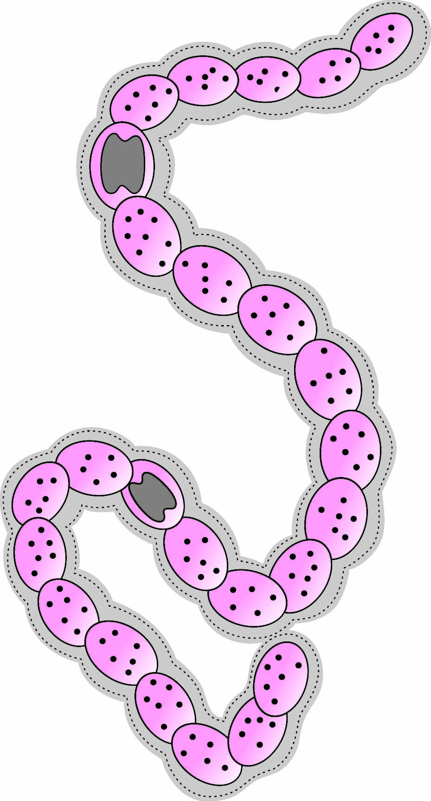

(A) **Part labelled as ‘i’** - Heterocyst, **‘i’ is a location for** - ATP production, **Kingdom to which the given organism belongs to** - Monera

(B) **Part labelled as ‘i’** - Mitochondria, **‘i’ is a location for** - Nitrogen fixation, **Kingdom to which the given organism belongs to** - Protista

(C) **Part labelled as ‘i’** - Heterocyst, **‘i’ is a location for** - Nitrogen fixation, **Kingdom to which the given organism belongs to** - Monera

(D) **Part labelled as ‘i’** - Mitochondria, **‘i’ is a location for** - ATP production, **Kingdom to which the given organism belongs to** - Protista

<C>

Organism shown in the diagram: *Nostoc*

**109.** Observe the given figure of organism and select the INCORRECT statement with respect to it.

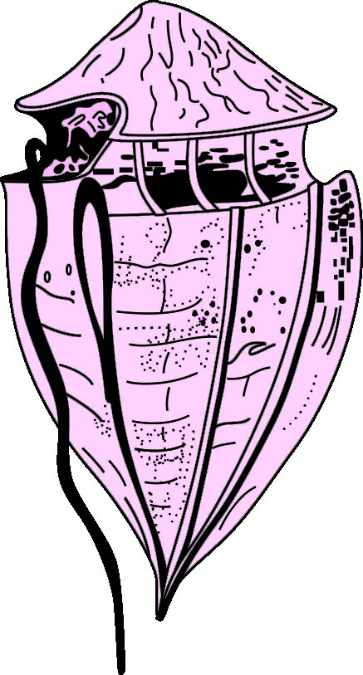

(A) These organisms undergo rapid multiplication causing red tides.

(B) Most of them have two flagella.

(C) These organisms lack flagella.

(D) These organisms belong to kingdom Protista.

<C>

The given figure is of Dinoflagellate and it is photosynthetic.

**110.** The organism shown in the given figure belongs to

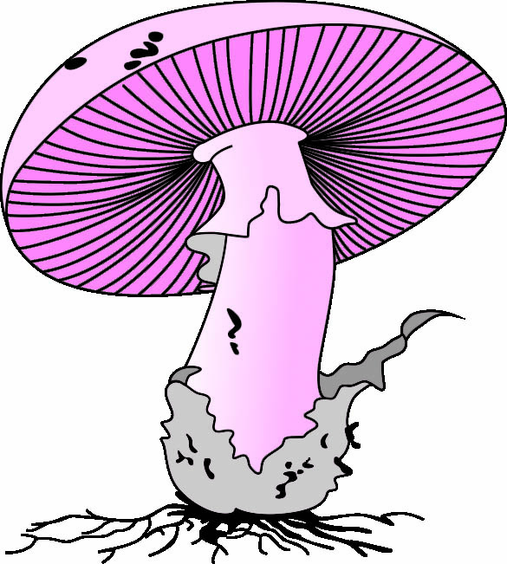

(A) Phycomycetes

(B) Ascomycetes

(C) Basidiomycetes

(D) Deuteromycetes

<C>

The given figure is of *Agaricus* (mushroom). It belongs to class Basidiomycetes.

**111.** Identify the structures marked as P and Q in the given figure.

P

Q

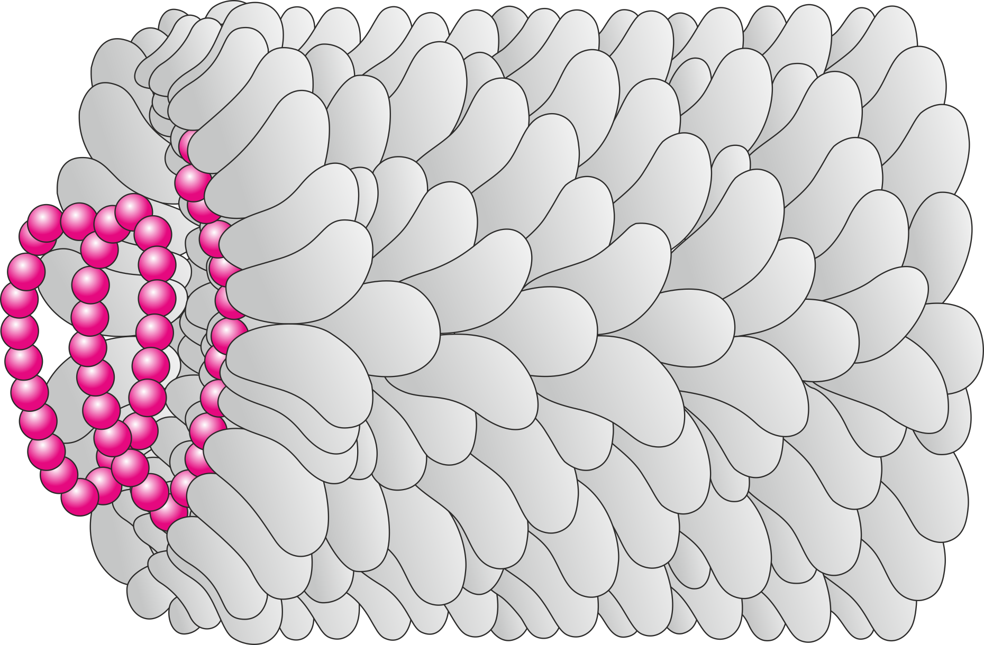

(A) **P** – RNA, **Q** – Capsomere

(B) **P** – RNA, **Q** – Capsid

(C) **P** – DNA, **Q** – Tail fibres

(D) **P** – DNA, **Q** – Capsid

<B>

Organism shown is Bacteriophage.

**112.** The given diagram is of a bacteriophage. Select the correct option for labelling (i), (ii), (iii) and (iv).

(iv)

(i)

(ii)

(iii)

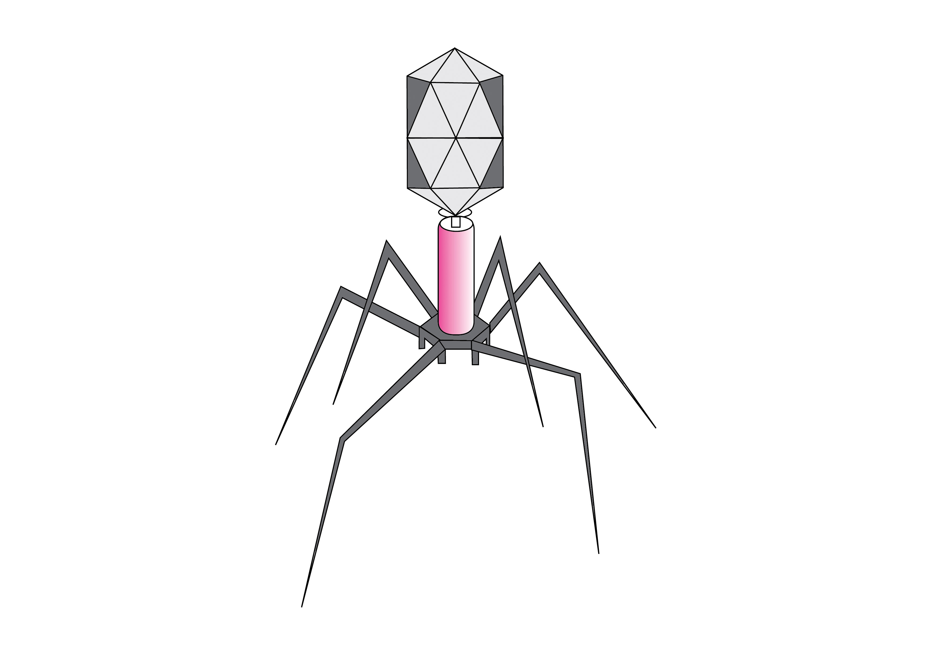

(A) i – Capsid, ii – Sheath, iii – Collar, iv – Tail fibres

(B) i – Head, ii – Collar, iii – Sheath, iv – Tail fibres

(C) i – Head, ii – Sheath, iii – Collar, iv – Tail fibres

(D) i – Capsid, ii – Collar, iii – Sheath, iv – Tail fibres

<B>

**Match the Columns**

**113.** Match the columns and select the correct option.

|  |  |  |  |
| --- | --- | --- | --- |
|  | **Column I (Scientist)** |  | **Column II**  **(Contribution)** |
| i. | Linnaeus | a. | Classification based on habitat |
| ii. | R.H. Whittaker | b. | Two-kingdom classification |
| iii. | Aristotle | c. | Five-kingdom classification |
| iv. | Carl Woese | d. | Three-domain classification |

(A) i – b, ii – d, iii – c, iv – a

(B) i – d, ii – c, iii – b, iv – a

(C) i – b, ii – c, iii – a, iv – d

(D) i – d, ii – b, iii – c, iv – a

<C>

**114.** Match the columns and select the correct option.

|  |  |  |  |
| --- | --- | --- | --- |
|  | **Column I (Bacteria)** |  | **Column II**  **(Shape)** |
| i. | Cocci | a. | Comma shaped |
| ii. | *Bacilli* | b. | Sphere shaped |
| iii. | Vibrio | c. | Rod shaped |
| iv. | *Spirilla* | d. | Spiral shaped |

(A) i – b, ii – d, iii – c, iv – a

(B) i – d, ii – c, iii – b, iv – a

(C) i – b, ii – c, iii – a, iv – d

(D) i – d, ii – b, iii – c, iv – a

<C>

***Think out of the box***

Spiral shaped bacteria are known as spirilla. Thus (iv-d). Only option **(C)** shows this combination. Hence the correct option is **(C)**.

**115.** Match Column I with Column II and select the correct option.

|  |  |  |  |
| --- | --- | --- | --- |
|  | **Column I**  **(TypesofArchaebacteria)** |  | **Column II (Habitat)** |
| i. | Methanogens | a. | Hot springs |
| ii. | Halophiles | b. | Marshy areas |
| iii. | Thermoacidophiles | c. | Salty areas |

(A) i – a, ii – c, iii – b

(B) i – b, ii – c, iii – a

(C) i – c, ii – b, iii – a

(D) i – c, ii – a, iii – b

<B>

**116.** Match the following and choose the correct combination from the options given below:

|  |  |  |  |
| --- | --- | --- | --- |
|  | **Column I** |  | **Column II** |
| i. | Chrysophytes | a. | *Paramecium* |
| ii. | Dinoflagellates | b. | *Euglena* |
| iii. | Euglenoids | c. | *Gonyaulax* |
| iv. | Protozoans | d. | Diatoms |

(A) i − a, ii − c, iii − b, iv − d

(B) i − a, ii − d, iii − c, iv − b

(C) i − d, ii − b, iii − c, iv − a

(D) i − d, ii − c, iii − b, iv − a

<D>

**117.** Match Column I with Column II and select the correct option.

|  |  |  |  |
| --- | --- | --- | --- |
|  | **Column I** |  | **Column II** |
| i. | Prions | a. | Protects nucleic acid |
| ii. | Capsid | b. | Decomposers |
| iii. | Viruses | c. | Cause mad cow disease in cattle |
|  |  | d. | Cause mumps |

(A) i − b, ii − d, iii − a

(B) i − c, ii − a, iii − d

(C) i − c, ii − d, iii − a

(D) i − d, ii − a, iii − c

<B>

**118.** Match Column I and Column II and select the correct option.

|  |  |  |  |
| --- | --- | --- | --- |
|  | **Column I** |  | **Column II** |
| i. | T.O. Diener | a. | *Contagium vivum fluidum* |
| ii. | M.W. Beijerinek | b. | Showed that viruses could be crystallised |
| iii. | Dmitri Ivanovsky | c. | Discovered a new infectious agent smaller than viruses |
| iv. | W.M. Stanley | d. | Recognised certain microbes as causal organism of the mosaic disease of tobacco |

(A) i – d, ii – b, iii – c, iv – a

(B) i – b, ii – c, iii – d, iv – a

(C) i – a, ii – c, iii – d, iv – b

(D) i – c, ii – a, iii – d, iv – b

<D>

**119.** Match the columns and select the correct option.

|  |  |  |  |
| --- | --- | --- | --- |
|  | **Column I** |  | **Column II** |
| i. | Slime moulds | a. | Show an infectious stage in life cycle |
| ii. | Dinoflagellates | b. | Saprophytic protists |
| iii. | Euglenoids | c. | Cause red tides |
| iv. | Sporozoans | d. | Flexible body due to the presence of pellicle |

(A) i – b, ii – c, iii – d, iv – a

(B) i – b, ii – d, iii – c, iv – a

(C) i – d, ii – c, iii – a, iv – b

(D) i – d, ii – a, iii – c, iv – b

<A>

**120.** Match the following fungi with their common names

|  |  |  |  |
| --- | --- | --- | --- |
|  | **Column – I** |  | **Column – II** |
| i. | Ascomycetes | a. | Imperfect fungi |
| ii. | Basidiomycetes | b. | Sac fungi |
| iii. | Deuteromycetes | c. | Algae fungi |
| iv. | Phycomycetes | d. | Bracket fungi |

(A) i – a, ii – c, iii – b, iv – d

(B) i – b, ii – d, iii – a, iv – c

(C) i – c, ii – a, iii – b, iv – d

(D) i – d, ii – b, iii – c, iv – a

<B>

**121.** Match Column I with Column II and select the correct option.

|  |  |  |  |
| --- | --- | --- | --- |
|  | **Column – I** |  | **Column – II** |
| i. | *Agaricus* (Fungi) | a. | Edible mushroom |
| ii. | *Neurospora* (Fungi) | b. | Model organism in genetics |
| iii. | Diatomaceous earth (Protista) | c. | Filtration & polishing |
| iv. | *Anabaena* (Monera) | d. | Nitrogen fixation in agriculture |

(A) i – a, ii – b, iii – c, iv – d

(B) i – b, ii – d, iii – a, iv – c

(C) i – c, ii – a, iii – b, iv – d

(D) i – d, ii – b, iii – c, iv – a

<A>

**NEET (UG) Previous Years’ Questions**

**122.** The primitive prokaryotes responsible for the production of biogas from the dung of ruminant animals, include the

(A) Methanogens

(B) Eubacteria

(C) Halophiles

(D) Thermoacidophiles

[NEET – Phase-I 2016]

<A>

**123.** Which one of the following is WRONG for fungi?

(A) They are both unicellular and multicellular.

(B) They are eukaryotic.

(C) All fungi possess a purely cellulosic cell wall.

(D) They are heterotrophic.

[NEET – Phase-II 2016]

<C>

In fungi, cell wall is usually composed of chitin.

**124.** Methanogens belongs to

(A) Eubacteria (B) Archaebacteria

(C) Dinoflagellates (D) Slime moulds

[NEET – Phase-II 2016]

<B>

Archaebacteria live in some of the most harsh habitats.

Methanogens belongs to archaebacteria and are mostly found in marshy areas.

**125.** Chrysophytes, Euglenoids, Dinoflagellates and Slime moulds are included in the kingdom

(A) Fungi (B) Animalia

(C) Monera (D) Protista

[NEET – Phase-I 2016]

<D>

**126.** Select the WRONG statement.

(A) Diatoms are microscopic and float passively in water.

(B) The walls of diatoms are easily destructible.

(C) ‘Diatomaceous earth’ is formed by the cell walls of diatoms.

(D) Diatoms are chief producers in the oceans.

[NEET – Phase-II 2016]

<B>

The walls of diatoms contain cellulose and silica. Thus the wall of diatoms is indestructible. They do not decay easily. After death, they are deposited at the bottom in water and form diatomaceous earth.

**127.** Which one of the following statements is wrong?

(A) Eubacteria are also called false bacteria.

(B) Phycomycetes are also called algal fungi.

(C) Cyanobacteria are also called blue-green

algae.

(D) Golden algae are also called desmids.

[NEET – Phase-I 2016]

<A>

Eubacteria are also called true bacteria.

**128.** One of the major components of cell wall of most fungi is

(A) chitin (B) peptidoglycan

(C) cellulose (D) hemicellulose

[NEET – Phase-I 2016]

<A>

**129.** Which of the following statements is WRONG for viroids?

(A) They cause infections.

(B) Their RNA is of high molecular weight.

(C) They lack a protein coat.

(D) They are smaller than viruses.

[NEET – Phase-I 2016]

<B>

The RNA of viroids is of low molecular weight.

**130.** Which among the following are the smallest living cells, known without a definite cell wall, pathogenic to plants as well as animals and can survive without oxygen?

(A) *Bacillus* (B) *Pseudomonas*

(C) Mycoplasma (D) *Nostoc*

[NEET – 2017]

<C>

**131.** Which of the following are found in extreme saline conditions?

(A) Archaebacteria (B) Eubacteria

(C) Cyanobacteria (D) Mycobacteria

[NEET – 2017]

<A>

**132.** Viroids differ from viruses in having

(A) DNA molecules with protein coat

(B) DNA molecules without protein coat

(C) RNA molecules with protein coat

(D) RNA molecules without protein coat

[NEET – 2017]

<D>

**133.** Which among the following is NOT a prokaryote?

(A) *Nostoc* (B) *Mycobacterium*

(C) *Saccharomyces* (D) *Oscillatoria*

[NEET – 2018]

<C>

*Saccharomyces* is a eukaryote.

**134.** Ciliates differ from all other protozoans in

(A) using pseudopodia for capturing prey

(B) having a contractile vacuole for removing excess water

(C) using flagella for locomotion

(D) having two types of nuclei

[NEET – 2018]

<D>

**135.** Which of the following organisms are known as chief producers in the oceans?

(A) Cyanobacteria (B) Diatoms

(C) Dinoflagellates (D) Euglenoids

[NEET – 2018]

<B>

**136.** After karyogamy followed by meiosis, spores are produced exogenously in

(A) *Agaricus* (B) *Alternaria*

(C) *Neurospora* (D) *Saccharomyces*

[NEET – 2018]

<A>

In *Agaricus*, spores are produced exogenously whereas in *Neurospora* and *Saccharomyces* spores are produced endogenously. *Alternaria* does not produce sexual spores.

**137.** Select the WRONG statement.

(A) Pseudopodia are locomotory and feeding structures in sporozoans.

(B) Mushrooms belong to Basidiomycetes.

(C) Cell wall is present in members of Fungi and Plantae.

(D) Mitochondria are the powerhouse of the cell in all kingdoms, except Monera.

[NEET – 2018]

<A>

Pseudopodia are locomotory and feeding structures in amoeboid protozoans.

**138.** Match the organisms in Column I with habitats in Column II.

|  |  |  |  |
| --- | --- | --- | --- |
|  | **Column-I** |  | **Column-II** |
| i. | Halophiles | a. | Hot springs |
| ii. | Thermoacidophiles | b. | Aquatic environment |
| iii. | Methanogens | c. | Guts of ruminants |
| iv. | Cyanobacteria | d. | Salty areas |

Select the correct answer from the options given below:

(A) i – b, ii – d, iii – c, iv – a

(B) i – d, ii – a, iii – c, iv – b

(C) i – a, ii – b, iii – c, iv – d

(D) i – c, ii – d, iii – b, iv – a

[NEET – Odisha 2019]

<B>

**139.** Which of the following statements is INCORRECT?

(A) Conidia are produced exogenously and ascospores endogenously.

(B) Yeasts have filamentous bodies with long thread - like hyphae.

(C) Morels and truffles are edible delicacies.

(D) *Claviceps* is a source of many alkaloids and LSD.

[NEET – 2019]

<B>

Yeasts lack filamentous structures called hyphae. It is a unicellular organism.

**140.** Match Column – I with Column – II.

|  |  |  |  |
| --- | --- | --- | --- |
|  | **Column – I** |  | **Column – II** |
| i. | Saprophyte | p. | Symbiotic association of fungi with plants roots |
| ii. | Parasite | q. | Decomposition of dead organic materials |
| iii. | Lichens | r. | Living on living plants or animals |
| iv. | Mycorrhiza | s. | Symbiotic association of algae and fungi |

Choose the correct answer from the options given below:

(A) i – b, ii – a, iii – c, iv – d

(B) i – b, ii – c, iii – d, iv – a

(C) i – a, ii – b, iii – c, iv – d

(D) i – c, ii – b, iii – a, iv – d

[NEET – 2019]

<B>

**141.** Which of the following statements is CORRECT?

(A) Lichens are not good pollution indicators.

(B) Lichens do not grow in polluted areas.

(C) Algal component of lichens is called mycobiont.

(D) Fungal component of lichens is called phycobiont.

[NEET – Odisha 2019]

<B>

Lichens are good pollution indicators as they do not grow in polluted areas.

**142.** Which of the following is INCORRECT about Cyanobacteria?

(A) They lack heterocysts.

(B) They often form blooms in polluted water bodies.

(C) They have chlorophyll 'a' similar to green plants.

(D) They are photoautotrophs.

[NEET – Phase-II 2020]

<A>

Cyanobacteria possess heterocyst that fixes atmospheric nitrogen to ammonia.

**143.** Which of the following is CORRECT about viroids?

(A) They have free RNA without protein coat.

(B) They have DNA with protein coat.

(C) They have free DNA without protein coat.

(D) They have RNA with protein coat.

[NEET – Phase-I 2020]

<A>

**144.** Which of the following statements is CORRECT?

(A) Some of the organisms can fix atmospheric nitrogen in specialized cells called sheath cells.

(B) Fusion of two cells is called Karyogamy.

(C) Fusion of protoplasm between two motile on non-motile gametes is called plasmogamy.

(D) Organisms that depend on living plants are called saprophytes.

[NEET – 2021]

<C>

Some of the organisms can fix atmospheric nitrogen in specialised cells called heterocysts e.g. *Nostoc* and *Anabaena.*

Karyogamy refers to fusion of two nuclei.

Organisms that depend on living plants are called primary consumers.

**145.** Which of the following is a CORRECT statement?

(A) Slime moulds are saprophytic organisms classified under Kingdom Monera.

(B) Mycoplasma have DNA, Ribosome and cell wall.

(C) Cyanobacteria are a group of autotrophic organisms classified under Kingdom Monera.

(D) Bacteria are exclusively heterotrophic organisms.

[NEET – 2022]

<C>

Slime moulds are saprophytic organisms classified under Kingdom Protista.

Mycoplasma lack cell wall.

Bacteria may be photosynthetic, chemosynthetic or heterotrophic.

**146.** Identify the asexual reproductive structure associated with *Penicillium.*

(A) Gemmules (B) Buds

(C) Zoospores (D) Conidia

[NEET – 2022]

<D>

**147.** Which one of the following is not a criterion for classification of fungi?

(A) Mode of spore formation

(B) Fruiting body

(C) Morphology of mycelium

(D) Mode of nutrition

[NEET – 2024]

<D>

**148.** Match List I with List II

|  |  |  |  |
| --- | --- | --- | --- |
|  | **List I** |  | **List II** |
| i. | *Rhizopus* | a. | Mushroom |
| ii. | *Ustilaga* | b. | Smut fungus |
| iii. | *Puccinia* | c. | Bread mould |
| iv. | *Agaricus* | d. | Rust fungus |

Choose the correct answer from the options given below:

(A) i-c, ii-b, iii-a, iv-d

(B) i-d, ii-c, iii-b, iv-a

(C) i-c, ii-b, iii-d, iv-a

(D) i-a, ii-c, iii-b, iv-d

[NEET – 2024]

<C>

**149.** Each of the following characteristics represent a Kingdom proposed by Whittaker. Arrange the following in increasing order of complexity of body organisation.

I. Multicellular heterotrophs with cell wall made of chitin.

II. Heterotrophs with tissue / organ / organ system level of body organisation.

III. Prokaryotes with cell wall made of polysaccharides and amino acids.

IV. Eukaryotic autotrophs with tissue/organ level of body organisation.

V. Eukaryotes with cellular body organisation.

Choose the correct answer from the options given below

(A) I, III,V, IV, II (B) III, V, I, II, IV

(C) I, III, V, II, IV (D) III, V, I, IV, II

[NEET – 2025]

<D>

**Topic Test**

**150.** *Anabaena* belongs to Kingdom

(A) Plantae (B) Protista

(C) Monera (D) Fungi

<C>

**151.** Rust is a

(A) Basidiomycete (B) Ascomycete

(C) Phycomycete (D) Slime mould

<A>

*Puccinia* is also called as rust fungus. It belongs to class basidiomycetes.

**152.** Read the statements given below and select the correct option.

I. Bryophytes belong to Kingdom Plantae.

II. Some plants are insectivorous.

III. Members of Kingdom Plantae are multicellular, prokaryotic and are complex.

IV. Mosses belong to Kingdom Plantae.

(A) Statements I and II are true.

(B) Statements I and III are true.

(C) Statements I, II and IV are true.

(D) All the statements are true.

<C>

Members of Kingdom Plantae are multicellular, eukaryotic and are complex.

**153.** Read the given statements regarding cyanobacteria and identify the correct one.

I. Cyanobacteria are unicellular, colonial or filamentous and are commonly found in most harsh habitats.

II. The colonies of cyanobacteria often blooms in polluted water bodies.

(A) Only I (B) Only II

(C) I and II (D) None of these

<C>

Archaebacteria are found in most harsh habitats. Cyanobacteria are freshwater / marine or terrestrial algae.

**154.** In the five-kingdom classification, *Chlamydomonas* and *Chlorella* have been included in

(A) Protista (B) Algae

(C) Plantae (D) Monera

<A>

**155.** Which bacteria is utilized in gobar gas plant?

(A) Methanogens

(B) Nitrifying bacteria

(C) Ammonifying bacteria

(D) Denitrifying bacteria

<A>

Methanogens produce methane (biogas) from the dung of animals such as cows and buffaloes.

**156.** Specialized cells for fixing atmospheric nitrogen in *Nostoc* are :

(A) Heterocysts (B) Hormogonia

(C) Nodules (D) Akinetes

<A>

Heterocysts are specialized cells found in certain filamentous cyanobacteria like *Nostoc*. Heterocyst has thick cell walls and lack photosynthetic pigments, allowing them to create an anaerobic environment suitable for nitrogenase enzymes to function efficiently in nitrogen fixation.

**157.** Algae differ from fungi in

(A) being heterotrophic

(B) being without motile gametes

(C) being without unicellular forms

(D) having chlorophyll and possessing cellulosic wall

<D>

Algae are photosynthetic and have cellulosic cell wall whereas fungi are heterotrophic and have chitinised wall.

**158.** Which one of the following organisms is NOT an example of eukaryotic cells?

(A) *Paramecium caudatum*

(B) *Escherichia coli*

(C) *Euglena viridis*

(D) *Amoeba proteus*

<B>

*Escherichia coli* is a prokaryote.

*Paramecium*, *Euglena* and *Amoeba* belong to kingdom Protista and are eukaryotes.

**159.** Which one of the following statements about viruses is CORRECT?

(A) Viruses possess their own metabolic system.

(B) Viruses contain either DNA or RNA.

(C) Viruses are facultative parasites.

(D) Viruses are readily killed by antibiotics.

<B>

Viruses do not have their metabolic machinery.

They are obligate parasites.

**160.** Lichens are well known combination of an alga and a fungus where fungus has

(A) a saprophytic relationship with the alga.

(B) an epiphytic relationship with the alga.

(C) a parasitic relationship with the alga.

(D) a symbiotic relationship with the alga.

<D>

**161.** Which of the following is NOT a criterion for classification of Five Kingdom System suggested by R.H. Whittaker?

(A) Presence or absence of a well-defined nucleus.

(B) Presence or absence of a true coelom.

(C) Autotrophic or heterotrophic mode of nutrition.

(D) Unicellular or multicellular body organisation.

<B>

**162.** Mycelium in members of group *Ascomycetes* is

(A) branched and septate

(B) unbranched and aseptate

(C) unicellular and branched

(D) unicellular and septate

<A>

**163.** Identify the ODD one out with respect to the kingdoms the given organisms belong to.

(A) Euglenoids (B) Phycomycetes

(C) Slime moulds (D) Dinoflagellates

<B>

Phycomycetes belong to Kingdom Fungi, while others belong to Kingdom Protista.

**164.** Which one of the following organism is NOT a parasite?

(A) *Trypanosoma* (B) *Entamoeba*

(C) *Plasmodium* (D) *Euglena*

<D>

**Your Turn**

**165.** Which of these processes introduces genetic variation in bacteria?

(A) Binary fission (B) Budding (C) Conjugation (D) Fragmentation

<C>

**166.** Which protist has a flexible body due to a pellicle instead of a cell wall?  
(A) *Euglena* (B) *Diatoms* (C) *Gonyaulax* (D) *Paramecium*

<A>

**167.** Slime moulds are considered saprophytic because they  
(A) Perform photosynthesis (B) Prey on smaller organisms

(C) Feed on decaying organic matter (D) Have chloroplasts

<C>

**168.** The cell wall of fungi is composed of:   
(A) Cellulose (B) Chitin (C) Peptidoglycan (D) Glycogen

<B>

**169.** Viroids differ from viruses in lacking ______.   
(A) Disease-causing ability (B) RNA

(C) Infectivity (D) Protein coat

<D>

**Check Your Grasp**

**170.** In hospitals, doctors often worry about the spread of antibiotic resistance genes among bacteria. A resistant bacterium can transfer its DNA to a sensitive bacterium through processes like conjugation, transformation, or transduction. However, microbiologists still report that bacteria reproduce only asexually.

Why is bacterial reproduction considered asexual in this context, even though genes are exchanged between cells?

Bacterial reproduction is considered asexual because the primary mode is binary fission, where one cell divides into two without gamete fusion or zygote formation. Genetic exchange via conjugation, transformation, or transduction only reshuffles DNA to introduce variability, but it does not create new bacterial cells. Thus, these are gene transfer processes, not reproductive ones.

**171.** A fisherman reports that the sea near his village has turned red, and dead fish are floating on the surface. Microscopic examination reveals organisms with cellulose plates and two flagella (one longitudinal, one transverse).  
Which group of Protists is most likely responsible, and why?

Dinoflagellates; their pigments cause red tides, and some release toxins, killing marine life.

**172.** During a medical camp in rural Africa, several patients complain of severe fatigue, fever, and disturbed sleep cycles. Blood smear examination reveals elongated protozoans with a single flagellum. The doctor suspects transmission by the bite of a tsetse fly.

Which Protist is responsible for this disease, and to which subgroup does it belong?

The disease is caused by *Trypanosoma*, a flagellated protozoan, which leads to African sleeping sickness.

**173.** A farmer notices that his crop roots are unusually healthy despite poor soil nutrition. On examination, the roots are found to be associated with fungal filaments.  
Which type of nutritional relationship explains this observation?

Symbiotic association (mycorrhiza), where the fungus helps in mineral and water absorption, while receiving carbohydrates from the plant.

**174.** A sterile knife used on diseased cattle is autoclaved but later still transmits a fatal neurodegenerative disease to another herd. Which agent is most consistent with this observation and why?

Prions, due to their misfolded protein structure that resists standard sterilisation like autoclaving.